Jousting Robot Senior Project
With Wireless Controller

Weekly Report 3

Ximing He
February 16, 2017

What I did last week
Update the components with joysticks.

What I plan to do next week
Update Arduino codes.

Challenges I am having
In my early prototype, I use seven push buttons total on the controller to construct commands, which depicts below.
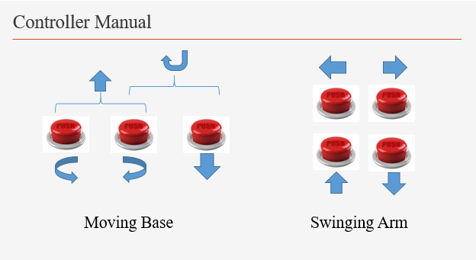
Each push button works well individually, but as our experience, when we deal with many push buttons, we will always, accidentally or intentionally, push multiple buttons at the same time. In my early prototype, I did a compromise design. As shown in the figure above, if left-turn and right-turn buttons are pressed simultaneously, the base moves forward; if left-turn (or right-turn) and backward buttons are pressed, the base makes left (or right) U-turn. Similarly, there are other combination of pushing multiple buttons. However, the problem happens on the swinging arm. If left-swing and right-swing buttons are pressed simultaneously, it contradicts understanding of movements. Similar condition applies for up-swing and down-swing buttons. Instead of using push buttons, I need to find something else. Joystick can do the trick.

Things I have achieved
Replacing push buttons with joystick is a perfect solution.
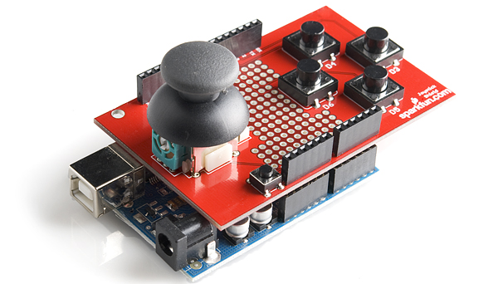
As shown in the figure above, a joystick can only have one moving direction. It cannot be directed to left and right at the same time. Therefore, a joystick can fully control the movement of the swing lance without contradiction. I am using two replace all seven buttons on the controller, both for the moving base and swing arm.
Another advantage of joystick is that it can control position and level. For each direction, the joystick can send out signals of how much we push it. In Arduino, it can send out analog signals of 0 to 1023 of all four directions when we push it. Because of the mechanics, at least two directions have to be 0 (we cannot push to left and to right at the same time). In my codes for my early prototype of Jousting Robot, I only consider digital signals because push buttons can only have state 0 (button not pushed) and 1 (button being pushed). Now I have to change my code to adapt the analog signals from joysticks.

How many hours I put into Senior Project this past week.
Four.

